Relevance of commodity derivatives in India: an analytical study of spot and future market
Minakshi Gourisaria

Abstract
This paper has analytically studied the commodity derivative markets in India and its relevance. In this study, it has been examined the price discovery function of commodity future market in India and also explore the volatility spillover between commodity spot and futures market. The price discovery function of the commodity market using the standard EGARCH framework and causality tests (percentages, ratio, growth trend, standard deviation, correlation, ‘t’ test, “GARCH”, skewness, Kurtosis, variances, standard deviation, mean, regression and beta value) has been incorporated. It has used the conventional cost of carry model to estimate the implied returns, which are useful in explaining the impact of monetary policy announcements and commodity price linkages. Research design of the study is both descriptive and analytical. It has been based on data collected from secondary sources from the year 2009-10 to 2013-14, the closing prices of future And spot market MCX.

The study has used simple linear regressions, correlations, Granger Causality tests to find the answer. The study has covered agricultural commodity like wheat for the Future (Close) and Spot (close) prices have been taken for measurement. It has found that wheat has the highest market price for spot market in the year 2012 -13 and future market in the year 2009-10. The study has shown that price discovery and market risk also can be assessed in that five years in both spot market and future market. So year wise along with total has been portrayed here for measurement. Price discovery is another important function of futures market and it hinges on whether new information in the market is reflected first in the changes in futures prices or changes in spot prices. Though price discovery futures market establishes a competitive reference (future) price from which spot price can be derived. Futures prices serve as the market expectations of subsequent spot prices for optimal decision making and resource allocation.

Keywords: commodity derivative, spot market, future market, price discovery, market risk
______________________________________________________________________________
Ph.D. Research Scholar, Utkal University, Bhubaneswar. ,email id: minakshigourisaria@gmail.com
INTRODUCTION
Commodity derivative came into the spotlight, when during the post- 1970 period; the US announced its decision to give up gold- dollar parity, the basic king pin of the Bretton Wood System of fixed exchange rates. With the dismantling of this system in 1971, exchange rates couldn’t be kept fixed. Interest rates became more volatile due to high employment and inflation rates. Less developed countries like India opened up their economies and allowed prices to vary with market conditions. Price fluctuations made it almost impossible for the corporate sector to estimate future production costs and revenues. The derivatives provided an effective tool to the problem of risk and uncertainty due to fluctuations in interest rates, exchange rates, stock market prices and the other underlying assets. The derivative markets have become an integral part of modern financial system in less than three decades of their emergence.
In the wake of globalization and surge in the global uncertainties, financial organizations around the globe are devising their methods and instruments to contain the price risk within these uncertainties of clouds. Commodity derivatives are such instruments that have been devised to achieve price risk management on basing the value of a security of an underlying commodity. A strong, healthy, vibrant and well developed commodity exchanges can play a pivotal role in the globalization of international trade by imparting a competitive pricing efficiency to exports. The promotion of derivatives trading has become imperative particularly, in the aftermath of WTO regime to face the challenges in terms of exposure to the vicissitudes of world commodity prices and heightened competition. In the Indian context, there are very few studies on the performance of the derivatives trading in select agricultural commodities.
The different types of commodity derivatives can range from energy sources and mined metals to textiles. Livestock, fruits and vegetables and raw materials from the forest are also included. Basically, all commodity derivatives are materials that are not of the financial type, such as stock options, bonds, and hard cash. One of the most profitable, and also one of the riskiest, commodity derivatives are energy sources, especially oil products that include crude oil, petrol, and propane. These energy sources have become very important commodities because many manufacturing companies need significant amounts of these fuels to run their factories and plants. For this reason, energy sources are very profitable, but their value can also be very unstable, especially when there are incidents such as wars and large-scale calamities. Renewable and “green” energy such as solar energy, hydroelectricity, and biofuel have also attracted more investors, in an effort to conserve natural resources. Metals are also valuable commodity derivatives that investors usually invest in, as they have been established as tangible symbols of economic and social status throughout history. Their value is also very stable and is not dependent on economic situations. Gold and silver are obviously among the most in demand metals, as they are used for expensive jewelries and for minting currency coins. Other precious metals include platinum, palladium, and rhodium. Metal alloys like steel are also valuable commodities as they are largely used for construction of buildings, skyscrapers and machines. Investors have also explored textile, livestock, and agricultural produce as commodity derivatives. These materials and resources are usually in high demand because they are expended for man’s daily necessities, especially for food. Livestock would usually include beef, chicken, pork, and sheep. Agricultural produce, on the other hand, is more varied, ranging from grains like corn, wheat, and oats, to other plants like coffee shrubs, cocoa trees, and sugarcane. Foods derived from plants have become so important that it is not uncommon for a developed country to buy a portion of land from a developing country’s territory to supply food for the former.
The spot market in commodities is controlled to a large extent by the State governments. There are restrictions on holding of stocks, turnover, and variation in taxes. The forward markets Commission performs the role of approving the rules and regulations of the exchanges subject to which the trading is to be conducted, accords Permission for commencement of trading in different contracts, monitor market condition and takes remedial measures. β risk and kurtosis risk also have technical implications in calculation of value at risk. If either is ignored, the Value at Risk calculations can be flawed. In options markets, the difference in implied volatility at different strike prices represents the market's view of skew, and is called volatility skew. (In pure Black–Scholes, implied volatility is constant with respect to strike and time to maturity.)
Stock volatility was a constant and known parameter, but the evidence for stochastically time-varying volatility is overwhelming. Most stochastic volatility models introduce a second stochastic process for variance, driven by shocks that are (negatively) correlated with the return process. But this makes volatility a latent variable and the volatility risk factors cannot be hedged, so they should logically carry risk premia. Estimating the variance equation requires sophisticated econometric methods whose small sample properties may be questioned. Generalized autoregressive conditional heteroskadasticity (GARCH) also offers a specification in which volatility is random, but both volatility and returns are driven by the same shocks, so the variance equation is fitted directly on the observed returns. GARCH specification captures time-varying volatility, including asymmetric response to up and down shocks, reversion toward a slowly time-varying long-run mean, non-affine and/or non-Gaussian shocks, and return processes subject to multiple shocks, including jumps.
PRODUCTS
Rate of volatility depends upon the price coefficient I.e. Price
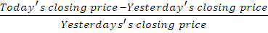 X100
This result has been taken for calculation the rate of volatility through variance, β, and kurtosis in tables and figures for the commodities for last five years i.e. 2009-10 to 2013-14.
A well developed spot commodities market with pure commercial interest helps in discovering the true price of commodities. An effective spot market is a barometer for efficient pricing mechanism as it is the market which is made of direct participation from farmers/producers, intermediaries, wholesalers, consumers, investors, etc. However, spot market will heavily depend on physical market infrastructure as well as cost of moving goods from one place to another, tax rate applicable to the particular commodity, etc. The commodity futures market is that they provide hedging against price risk. Hedging is the practice of offsetting the price risk in a cash market position by taking an equal and opposite position in the futures market. By taking a position in the futures market that is opposite to that held in the spot market, the producer can offset the losses in the latter with the gains in the former. Hedgers use the futures market to mitigate their price risk while speculators seek to profit from the price movements in the market and in doing so they provide much needed liquidity to the market.
Another important function of futures market is price discovery. Price signals are essential for the firms to take their production & marketing decisions. Price discovery is the process of buyers and sellers arriving at a transaction price for a given commodity. It also implies how information is produced and transmitted across markets and whether these transmitted prices can be used as a reference price for the trading needs. Proper price discovery can help farmers and traders in avoiding price slumps in the post harvest period and also help consumers in coping with price volatility. If new information is reflected first in futures prices, the futures markets are said to perform the price discovery function efficiently. Futures markets also provide support for credit needs to small producers. The collateral value of inventory is enhanced if it is hedged; enabling firms to borrow on better terms.
Analysis of Commodities in Spot and Future Market from 2009-10 to 2013-14
Individual year wise measurements of agricultural commodities i.e. wheat have been incorporated to compare the rate of volatility and price discovery in both spot and future market.

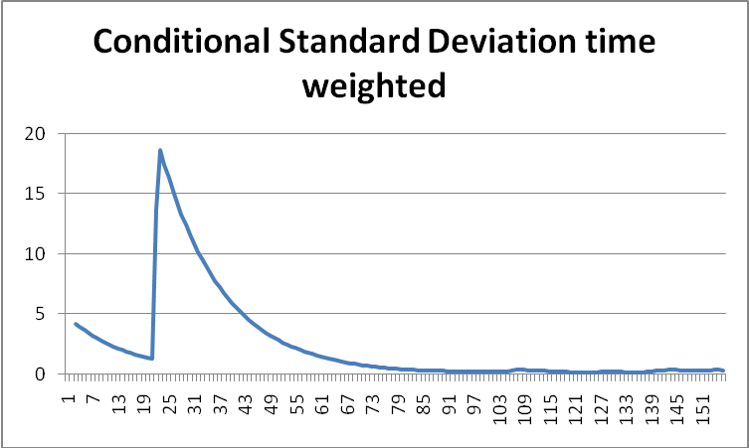
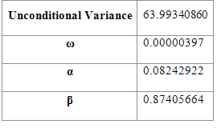
Analysis of wheat (Spot-2009)
Fig-1.11. showing the volatility of wheat trading in Future in 2009-2010

Table-1.11. showing the results of Garch coefficients of wheat in Spot during 2009-2010

Table-1.11 indicates the measurement of price volatility of wheat in Spot market during the financial period of 2009-10, and the unconditional variance indicate 63.9934, which is higher value and reported a higher degree of volatility .Further, it is supported by β results i.e. 0.8740, which is also closer to one, indicates a positive variation in the normal trend . Kurtosis coefficient indicates a short period of fluctuation during the period. So it is concluded that wheat is highly volatile in the market price of Spot market.
Figure – 1.11 highlights the spot price of wheat during 2009-10. It indicates a short span high tailed kurtosis and the deviation is marked a little, indicates a positive variation in the normal trend. The short periods of fluctuation have prevailed during the period. So it is concluded that wheat is highly volatile in the market price of spot but at the end, it marked a negative price than the average trend and indicates a higher volatility in the trend. So chance of price recovery is less during the period, if the investor prefers.
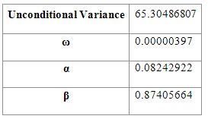
Analysis of wheat (Future-2009)
Fig-1.12. showing the volatility of wheat trading in Future in 2009-2010

Table-1.12. showing the results of Garch coefficients of wheat in Future during 2009-2010

Table-1.12 indicates the measurement of price volatility of wheat in future market during the financial period of 2009-10, and the unconditional variance indicate 65.3048, which is higher value and reported a higher degree of volatility .Further, it is supported by β results i.e. 0.8740, which is also closer to one, indicates a positive variation in the normal trend . Kurtosis coefficient indicates a short period of fluctuation during the period. So it is concluded that the wheat is highly volatile in the market price of future market and risk is less.
Figure – 1.12 highlights the future price of wheat during 2009-10. It indicates a short span high tailed kurtosis and the deviation is marked a little, indicates a positive variation in the normal trend. The short periods of fluctuation have prevailed during the period. So it is concluded that wheat is less volatile in the market price of future but at the end, it marked a negative price than the average trend and indicates a higher volatility in the trend. So chance of price recovery is less during the period, if the investor prefers.
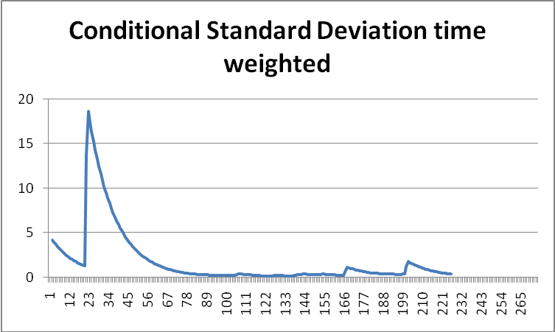
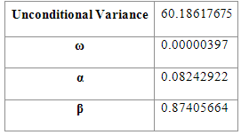
Analysis of wheat (Spot-2010)
Fig-1.13. showing the volatility of wheat trading in Spot in 2010-2011

Table-1.13. showing the results of Garch coefficients of wheat in Spot during 2010-2011

Table-1.13 indicates the measurement of price volatility of wheat in Spot market during the financial period of 2010-11, and the unconditional variance indicate 60.1861, which is higher value and reported a higher degree of volatility .Further, it is supported by β results i.e. 0.8740, which is also closer to one, indicates a positive variation in the normal trend Kurtosis coefficient indicates a short period of fluctuation during the period. So it is concluded that the wheat is highly volatile in the market price of Spot market.
Figure – 1.13 highlights the spot price of wheat during 2010-11. It indicates a short span high tailed kurtosis and the deviation is marked a little, indicates a positive variation in the normal trend. The short periods of fluctuation have prevailed during the period. So it is concluded that wheat is highly volatile in the market price of spot but at the end, it marked a negative price than the average trend and indicates a higher volatility in the trend. So chance of price recovery is less during the period, if the investor prefers
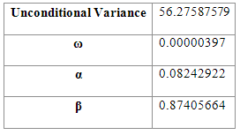
Analysis of wheat (Future-2011)
Fig-1.14. showing the volatility of wheat trading in Future in 2010-2011

Table-1.14. showing the results of Garch coefficients of wheat in Future during 2010-2011

Table-1.14 indicates the measurement of price volatility of wheat in future market during the financial period of 2010-11, and the unconditional variance indicate 56.2758, which is greater and reported a higher degree of volatility .Further, it is supported by β results i.e. 0.8740, which is also closer to one, indicates a positive variation in the normal trend . Kurtosis coefficient indicates a short period of fluctuation during the period. So it is concluded that the wheat is highly volatile in the market price of future market.
Figure – 1.14 highlights the future price of wheat during 2010-11. It indicates a short span high tailed kurtosis and the deviation is marked a little, indicates a positive variation in the normal trend. The short periods of fluctuation have prevailed during the period. So it is concluded that wheat is highly volatile in the market price of future but at the end, it marked a negative price than the average trend and indicates a higher volatility in the trend. So chance of price recovery is less during the period, if the investor prefers
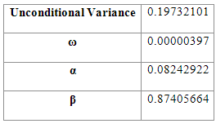
Analysis of wheat (Spot-2011)
Fig-1.15. showing the volatility of wheat trading in Spot in 2011-2012

Table-1.15. showing the results of Garch coefficients of wheat in Spot during 2011-2012

Table-1.15 indicates the measurement of price volatility of wheat in Spot market during the financial period of 2011-12, and the unconditional variance indicate 0.1937, which is lower value and reported a lower degree of volatility .Further, it is supported by β results i.e. 0.8740, which is also closer to one, indicates a positive variation in the normal trend . Kurtosis coefficient indicates a short period of fluctuation during the period. So it is concluded that the wheat is less volatile in the market price of Spot market and risk is less.
Figure – 1.15 highlights the spot price of wheat during 2011-12. It indicates a short span high tailed kurtosis and the deviation is marked a little, indicates a positive variation in the normal trend. The short periods of fluctuation have prevailed during the period. So it is concluded that wheat is less volatile in the market price of future but at the end, it marked a negative price than the average trend and indicates a higher volatility in the trend. So chance of price recovery is less during the period, if the investor prefers
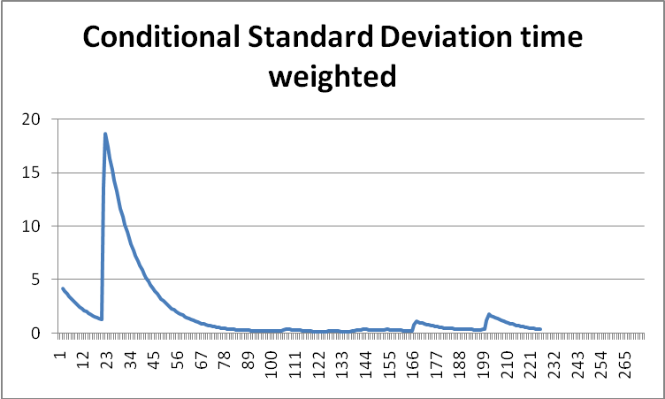
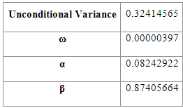
Analysis of wheat (Future-2011)
Fig-1.16. showing the volatility of wheat trading in Future in 2011-2012

Table-1.16. showing the results of Garch coefficients of wheat in Future during 2011-2012

Table-1.16 indicates the measurement of price volatility of wheat in future market during the financial period of 2011-12, and the unconditional variance indicates 0.3241, which is lower value and reported a lower degree of volatility .Further, it is supported by β results i.e. 0.8740, which is also closer to one, indicates a positive variation in the normal trend . Kurtosis coefficient indicates a short period of fluctuation during the period. So it is concluded that wheat is less volatile in the market price of future market and risk is less.
Figure – 1.16 highlights the future price of wheat during 2011-12. It indicates a short span high tailed kurtosis and the deviation is marked a little, indicates a positive variation in the normal trend. The short periods of fluctuation have prevailed during the period. So it is concluded that wheat is less volatile in the market price of future but at the end, it marked a negative price than the average trend and indicates a higher volatility in the trend. So chance of price recovery is less during the period, if the investor prefers.
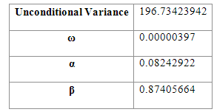
Analysis of wheat (Spot-2012)
Fig-1.17. showing the volatility of wheat trading in Spot in 2012-2013

Table-1.17. showing the results of Garch coefficients of wheat in Spot during 2012-2013

Table-1.17 indicates the measurement of price volatility of wheat in Spot market during the financial period of 2012-13, and the unconditional variance indicate 196.73, which is higher value and reported a higher degree of volatility .Further, it is supported by β results i.e. 0.8740, which is also closer to one, indicates a positive variation in the normal trend . Kurtosis coefficient indicates a short period of fluctuation during the period. So it is concluded that the wheat is highly volatile in the market price of Spot market and risk is high.
Figure – 1.17 highlights the future price of wheat during 2012-13. It indicates a short span high tailed kurtosis and the deviation is marked a little, indicates a positive variation in the normal trend. The short periods of fluctuation have prevailed during the period. So it is concluded that wheat is less volatile in the market price of spot but at the end, it marked a negative price than the average trend and indicates a higher volatility in the trend. So chance of price recovery is less during the period, if the investor prefers.
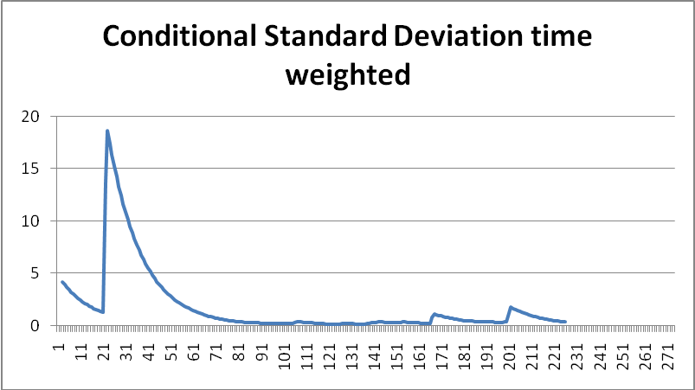
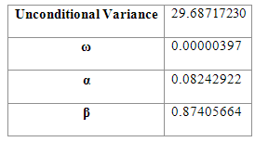
Analysis of wheat (Future-2012)
Fig-1.18. showing the volatility of wheat trading in Future in 2012-2013

Table-1.18. showing the results of Garch coefficients of wheat in Future during 2012-2013

Table-1.18 indicates the measurement of price volatility of wheat in future market during the financial period of 2012-13, and the unconditional variance indicate 29.6871, which is higher value and reported a higher degree of volatility .Further, it is supported by β results i.e. 0.8740, which is also closer to one, indicates a positive variation in the normal trend Kurtosis coefficient indicates a short period of fluctuation during the period. So it is concluded that the wheat is highly volatile in the market price of future market.
Figure – 1.18 highlights the future price of wheat during 2012-13. It indicates a short span high tailed kurtosis and the deviation is marked a little, indicates a positive variation in the normal trend. The short periods of fluctuation have prevailed during the period. So it is concluded that wheat is less volatile in the market price of future but at the end, it marked a negative price than the average trend and indicates a higher volatility in the trend. So chance of price recovery is less during the period, if the investor prefers.
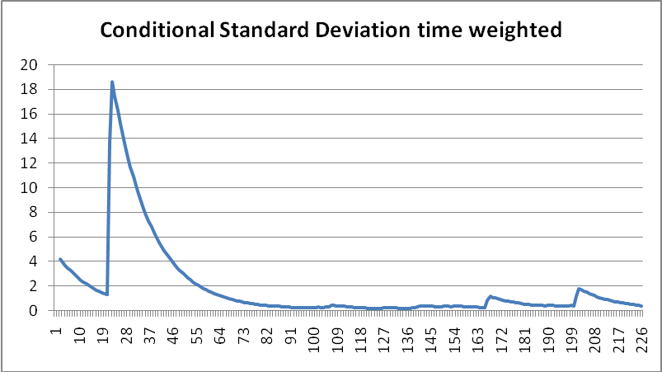
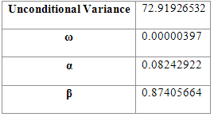
Analysis of wheat (Spot-2013)
Fig-1.19. showing the volatility of wheat trading in Spot in 2013-2014

Table-1.19. showing the results of Garch coefficients of wheat in Spot during 2013-2014

Table-1.19 indicates the measurement of price volatility of wheat in Spot market during the financial period of 2013-14, and the unconditional variance indicates 72.9192, which is higher value and reported a higher degree of volatility .Further, it is supported by β results i.e. 0.8740, which is also closer to one, indicates a positive variation in the normal trend Kurtosis coefficient indicates a short period of fluctuation during the period. So it is concluded that the zinc is highly volatile in the market price of Spot market and risk is less.
Figure – 1.19 highlights the spot price of wheat during 2013-14. It indicates a short span high tailed kurtosis and the deviation is marked a little, indicates a positive variation in the normal trend. The short periods of fluctuation have prevailed during the period. So it is concluded that wheat is less volatile in the market price of future but at the end, it marked a negative price than the average trend and indicates a higher volatility in the trend. So chance of price recovery is less during the period, if the investor prefers
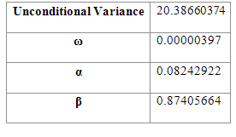
Analysis of wheat (Future-2013)
Fig-1.20. showing the volatility of wheat trading in Future in 2013-2014

Table-1.20. showing the results of Garch coefficients of wheat in Future during 2013-2014

Table-1.20 indicates the measurement of price volatility of wheat in future market during the financial period of 2013-14, and the unconditional variance indicate 20.3866, which has higher value and reported a higher degree of volatility .Further, it is supported by β results i.e. 0.8740, which is also closer to one, indicates a positive variation in the normal trend . Kurtosis coefficient indicates a short period of fluctuation during the period. So it is concluded that wheat is highly volatile in the market price of future market and risk is less.

Figure – 1.20 highlights the future price of wheat during 2013-14. It indicates a short span high tailed kurtosis and the deviation is marked a little, indicates a positive variation in the normal trend. The short periods of fluctuation have prevailed during the period. So it is concluded that wheat is less volatile in the market price of future but at the end, it marked a negative price than the average trend and indicates a higher volatility in the trend. So chance of price recovery is less during the period, if the investor prefers.
Conclusions
From the above case studies it has found that wheat has the highest market price for spot market in the year 2012 -13 and future market in the year 2009-10. Wheat market is mostly based on risk and price discovery is difficult as strict rules and regulation of the government are imposed and it depends upon a number of factors. So in 2011-12, it is marked a less volatile in its price but in other years, high and peak differences in the market prices have been marked, which is not favorable for investment.

References:
- Jackline, S. and Deo, Malabika (2011). “Lead Lag Relationship between Futures and Spot Prices”. Journal of Economics and International Finance 3(7): pp 424-427.
- Sen, Abhijit (2008). “Report of the Expert Committee to Study the Impact of Futures Trading on Agriculture Commodity Prices”. Submitted to Ministry of Consumer Affairs, Food & Public Distribution Government of India.
- Bose, S. (2008). “Commodity Futures Market in India - A Study of Trends in the Notional Multi- Commodity Indices”. ICRA Bulletin of Money and Finance.
- Nath, G. C. and Lingareddy, T. (2008). “Commodity derivative market and its Impact on Spot Market”. Working Paper Series.
- Abuja, N. L. (2006). “Commodity Derivatives Market in India: Development, Regulation and Future Prospects”. International Research Journal of Finance and Economics.
- Wuensch, K. L. (2005). “Skewness. In B. S. Everitt& D. C. Howell (Eds.)”. Encyclopedia of statistics in behavioral science: pp. 1855 - 1856 Chichester, UK: Wiley.
- Wuensch, K. L. (2005). “Kurtosis. In B. S. Everitt& D. C. Howell (Eds.)”. Encyclopedia of statistics in behavioral science: pp. 1028 - 1029 Chichester, UK: Wiley.
- Armesto, M.T. and Gavin, W.T. (2005). “Monetary Policy and Commodity Futures”. Federal Reserve Bank of St. Louis Review 87(3): pp 395-405.
- Pindyck, R. S. (2001). “The Dynamics of Commodity Spot and Future Markets: A Primer”. Massachusetts Institute of Technology Cambridge, A 02142.
- Marlowe, J. (2000). “Hedging Currency Risk and Options and Futures”.
- Morgan, C.W. (1999). “Futures Markets and Spot Price Volatility: A Case Study”. Journal of Agricultural Economics 50: pp 247-57.
- Joanes, D. N. and Gill, C. A. (1998). “Comparing measures of sample skewness and kurtosis”. Journal of the Royal Statistical Society (Series D): The Statistician 47 (1): pp 183–189.
- Netz, J.S. (1995). “The Effect of Futures Markets and Corners on Storage and Spot Price Volatility”. American Journal of Agricultural Economics 7: pp 182-93.
- Cuny, C.J. (1993). “The Role of Liquidity in Futures Market Innovations”. Review of Financial Studies 6: pp 57-78.
- Pearson, K. (1895). “Contributions to the mathematical theory of evolution, II: Skew variation in homogeneous material”. Philosophical Transactions of the Royal Society of London 186: pp 343-414.

